**Mrs. Alvarado’s Classroom News**

September 26, 2014

**General Information and Reminders**

* Thank you to all of you who attended your child’s conference this week. It was a pleasure meeting with you and sharing your child’s progress.
* Mark your calendars for Eaglefest, which will be held on Friday, October 17th from 5:00 – 8:00. Please make plans to attend this Walnut Grove annual tradition!
* Monday, October 6, 2014 at 6:30 is Technology Night. Please make plans to attend.
* Mark your calendars for the next Chick-fil-A night which will be held on October 9th! Stop by for some delicious food for a good cause.
* Monday, October 13, 2014 is a student holiday.
* Don’t forget to send in your donations to the eaglefest for our classroom!
* Please begin to gather the supplies to help our book basket grow!

**Curriculum Notes**

In Math we continued our unit on fractions. We shifted our focus to equal sharing, and did many fun activities involving Hershey’s candy bars, cookie crisp cereal, and pizza.

In Language Arts this past week, we focused on a number of skills. We began talking about blends and continued discussing short I word families. Next week, we will continue to introduce new reading strategies. In our writing block, we spent a great deal of time talking about conventions in our writing. Next week in writing we will shift our focus to using transition words in writing. Continue to read with your child nightly and discuss the characters, setting, as well as the beginning, middle, and end of the story, as these are all skills that we have worked on in class. Thank you for all of your support!

**Next Week’s Specials Rotation**

* **Monday- *PE**
* **Tuesday- Art**

**Wednesday-STEM**

* **Thursday- *PE**
* **Friday- Art**

**\*Please remember to wear sneakers on P.E. days. \***

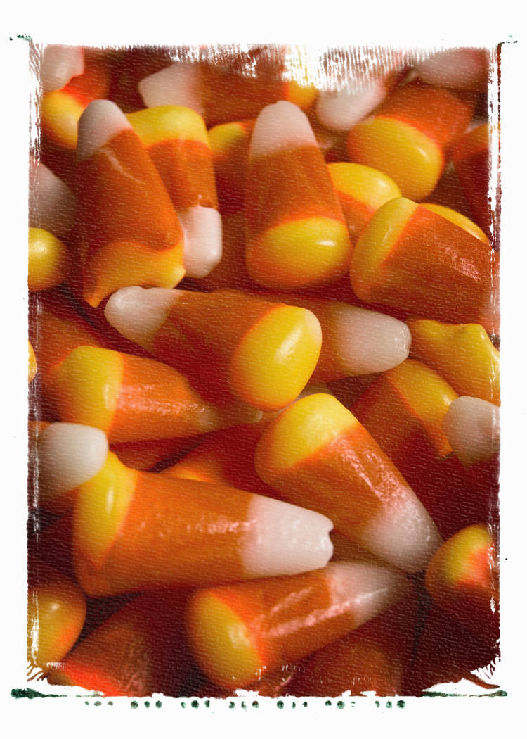



I am very excited about continuing to work together with you and your student as the year continues!

Educationally yours,

**Mrs. Alvarado**